**Project Design Phase-I Solution Architecture**

|  |  |
| --- | --- |
| Team ID | PNT2022TMID26821 |
| Project Name | Project - IOT Based Safety Gadget for Child  Safety Monitoring and Notification |
| Maximum Marks | 4 Marks |

**Solution Architecture:**

➤ Using the Minimum Viable Architecture model can ultimately result in a highly polished end product as it relies on testing assumptions with small experiments and guiding

development using the ﬁndings of said experiments.

➤ Providing a ﬂexible framework that can help achieve target business objectives, MVA responds to evolving customer requirements and technologies and can go a long way in

promoting agility.

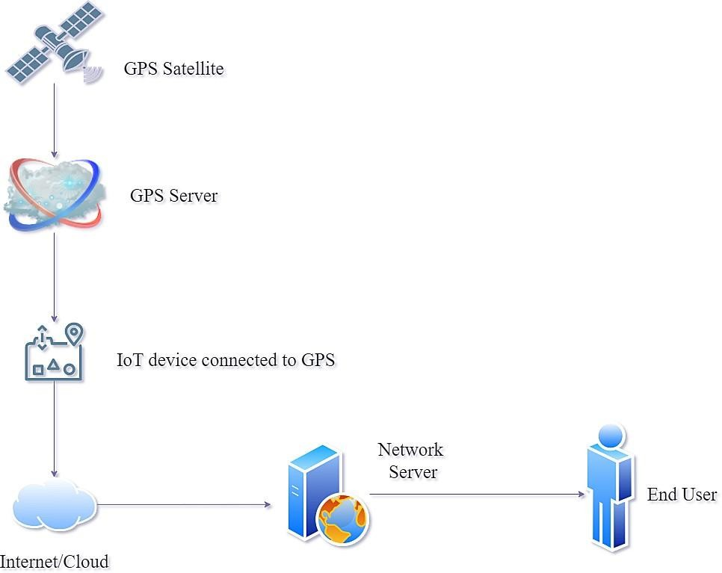

 The safety of a child at a large public event is a major concern for event organizers and parents. We address this important concern and proposes an architecture model of the IoT-enable smart child safety tracking digital system.

 This IoT-enabled digital system architecture integrates the Cloud, Mobile and GPS

technology to precisely locate the geographical location of a child on an event map.

 The proposed architecture model describes the people, information, process, and technology architecture elements, and their relationships for the complex IoT-enable smart child safety tracking digital system.

Outline Architecture:

